**DAY9- ASSIGNMENT**

BATCH NAME: SAP ABAP HANA

NAME: PAMPANABOINA VANDANA

EMP ID:46255266

EMP EMAIL ID: PAMPANABOINA.VANDANA@CAPGEMINI.COM

**Exercise 1 – Table Enhancement Using Append Structure**

**Hints:**

1. Cannot be added in more than one table.
2. Append structures cannot be added to a table who’s last field has data type LCHAR or LRAW.

**Requirement:**

**Append custom fields ZZDISCOUNT1 to ZZDISCOUNT5 in the standard table SFLIGHT.**

This table is used to store flight details such Flight Date, Airfare, Maximum capacity in economy class, and Occupied seats in economy class for an airline carrier and needs to be enhanced to store discounts available for each flight if applicable.

**Transaction –** Use your own Tcode like ZYP01…ZY to display data

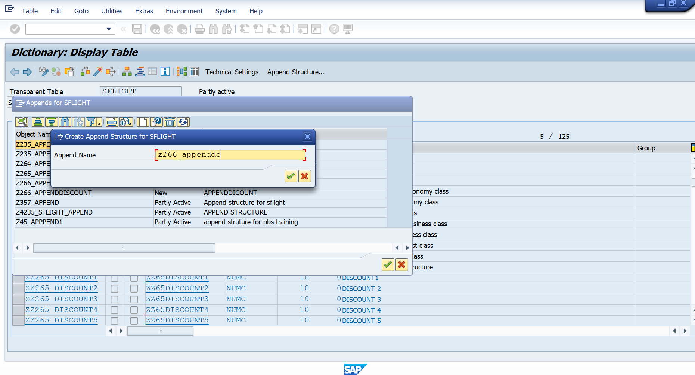

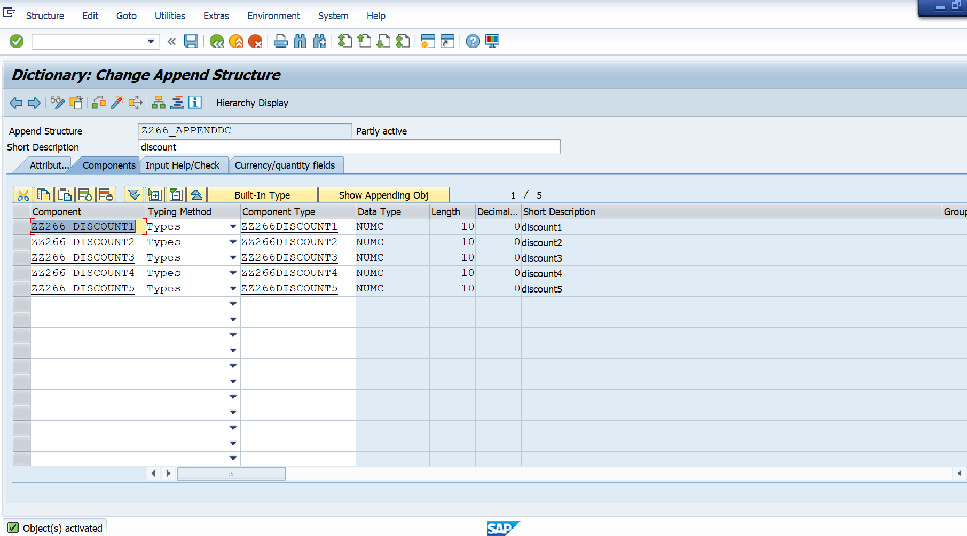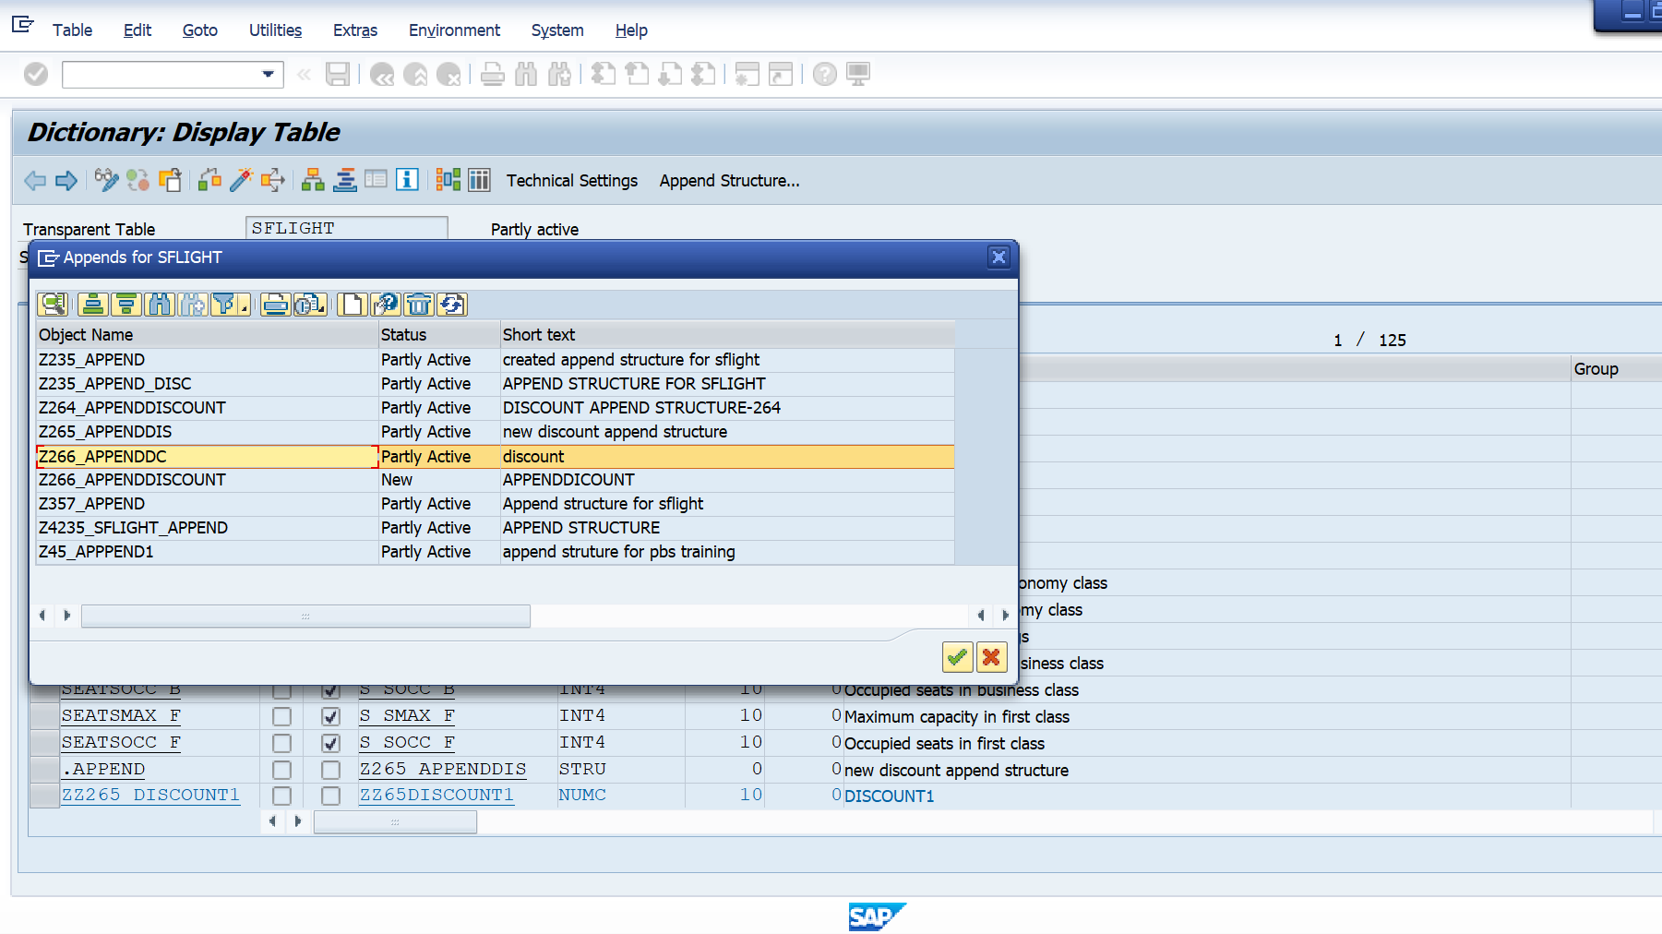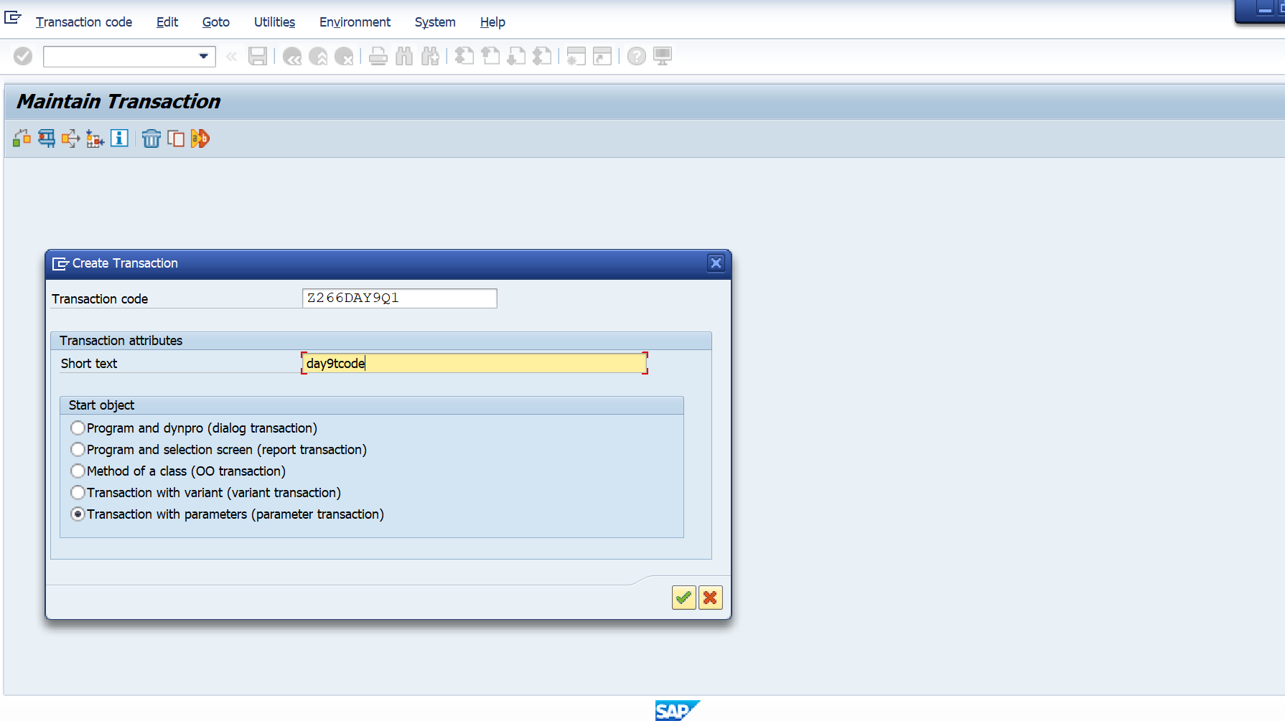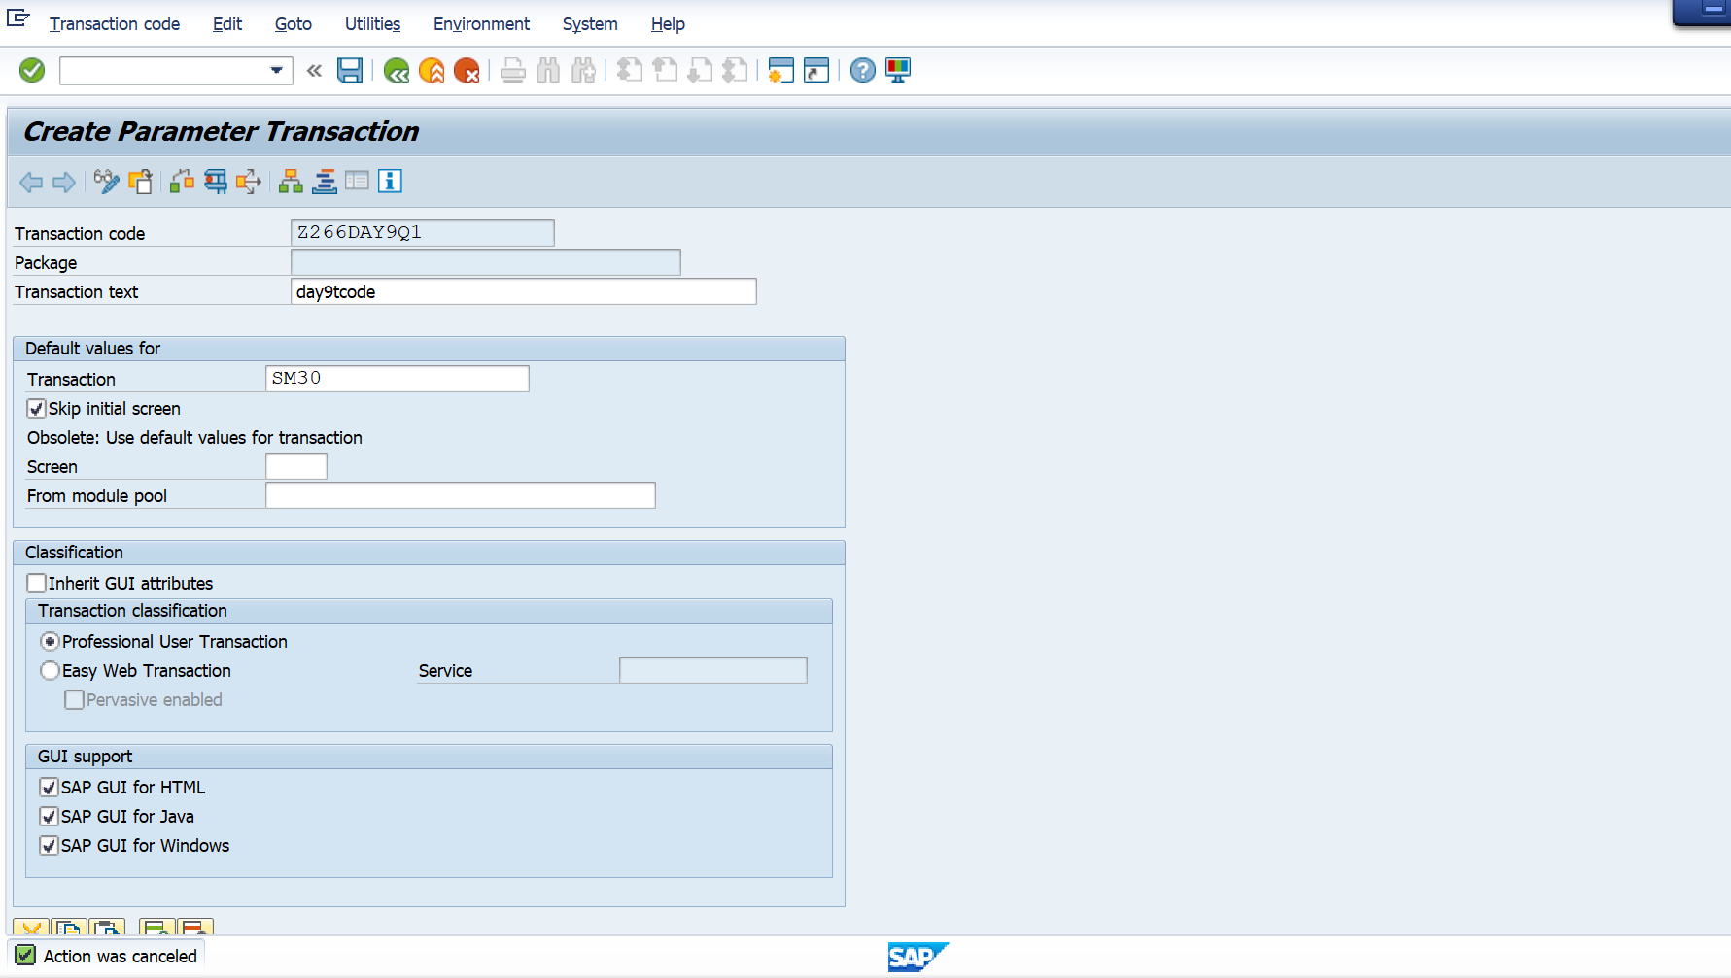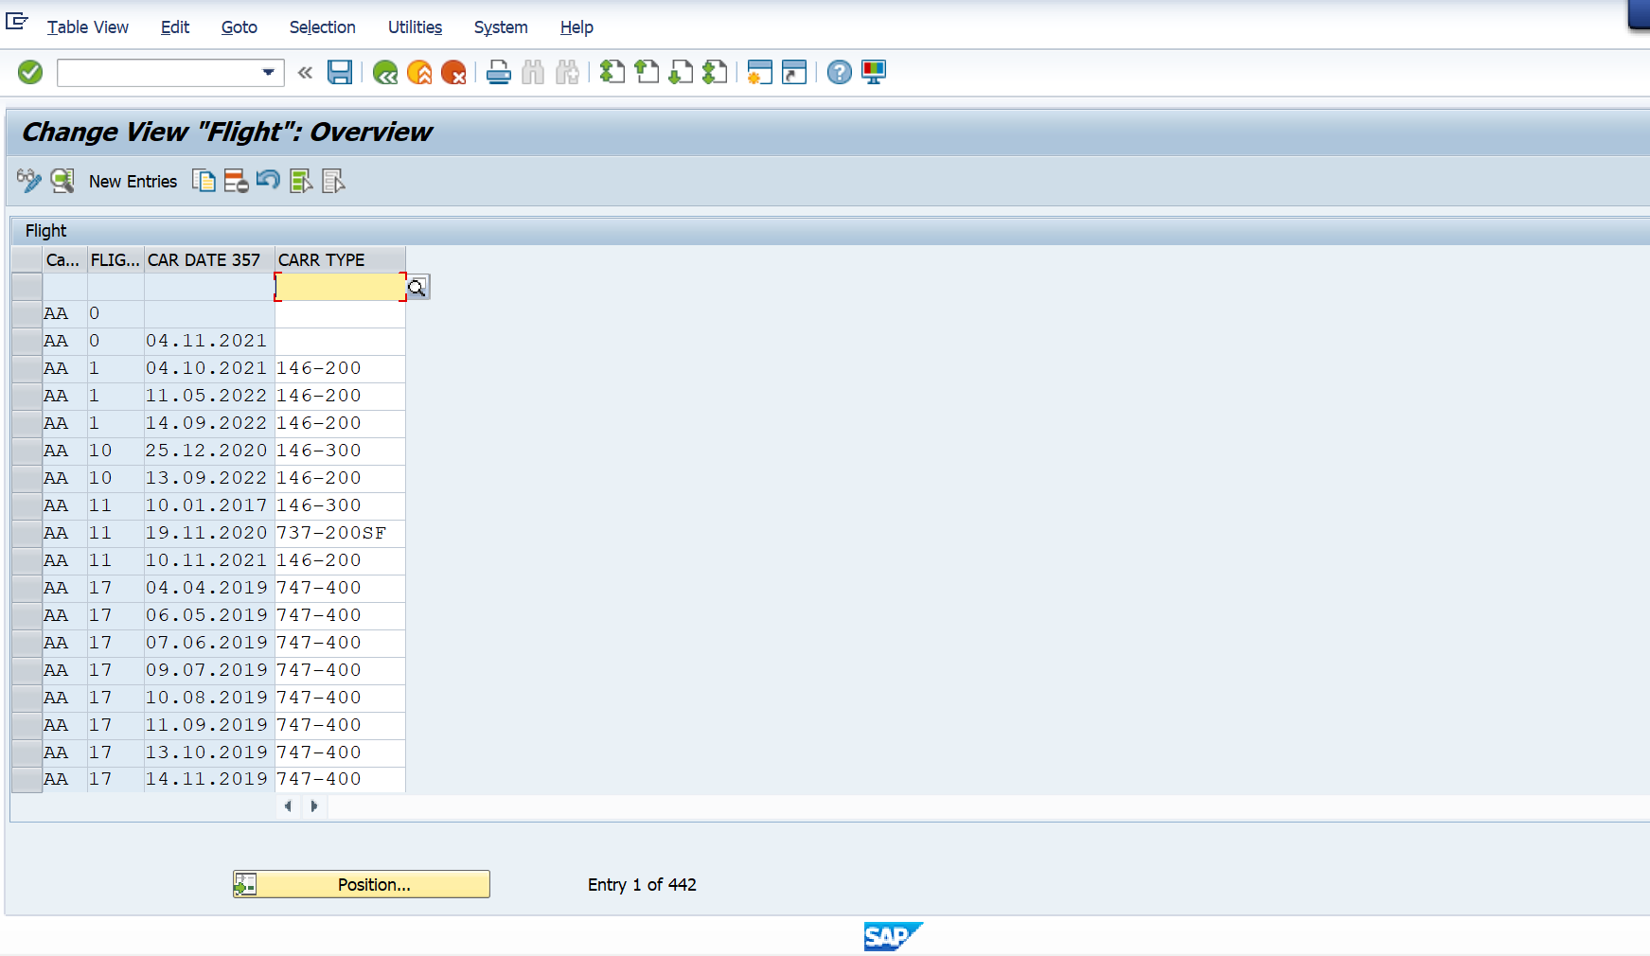**Exercise 2 – Table Enhancement Using Customizing Include**

**Hints:**

1. Preplanned by SAP and provided in standard sap tables to add custom fields.
2. Can be available in more than one table, as these are planned by SAP.
3. These includes are part of custom exits.

**Requirement:**

**Append custom fields ZZNAME1 to ZZNAME5 in the standard table EKKO *using* customizing include if available.**

This table is used to store purchase order details, which needs to be enhanced to store user names that creates the purchase orders.

**Transaction –** ME21N, ME22N & ME23N is used to create, change or display purchase orders.

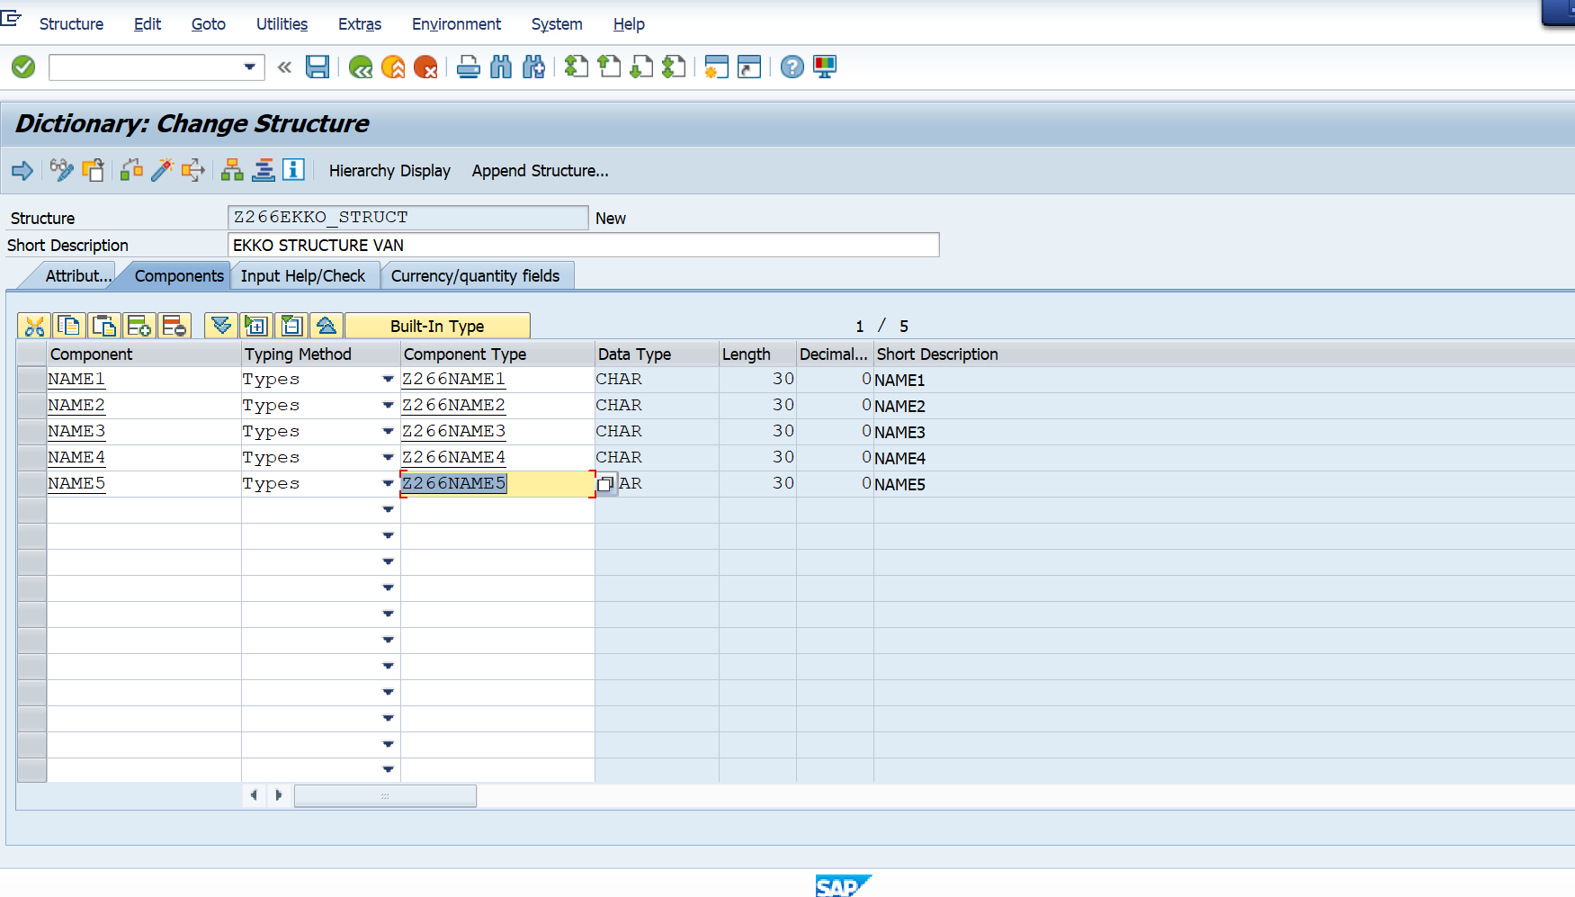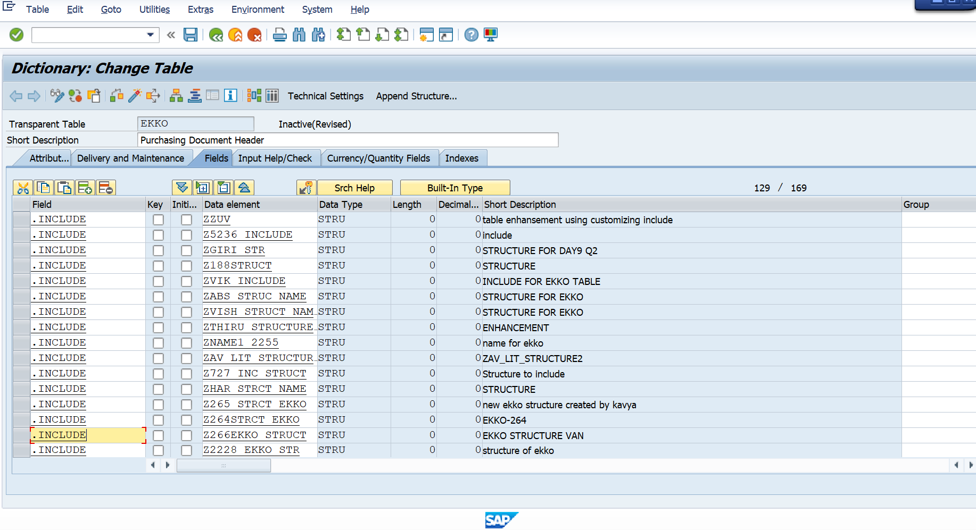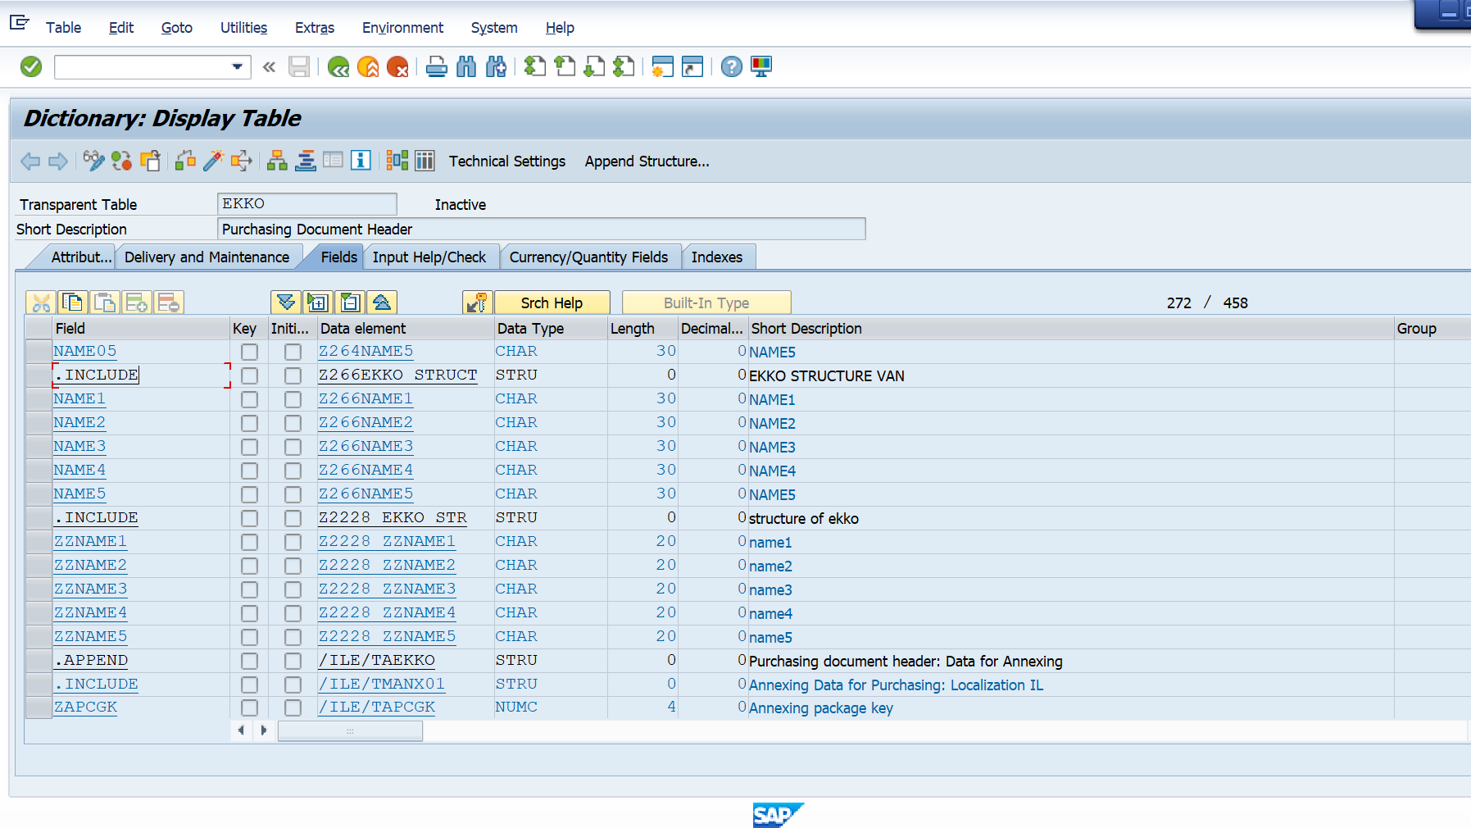

**Exercise 3 – Text Enhancements**

**Hints:**

1. These are global enhancements and these changes are visible in all transactions where these data elements are used.
2. You can restore sap or customer versions of field labels after upgrades
3. Execute transaction CMOD.
4. For Field Label - Navigate to ->Goto->Text enhancements->Keywords->Change
5. For Documentation - Navigate to ->Goto->Text enhancements->Data Elements->New Cust

**Requirement: Change field labels and documentation for transaction** ZYP01 **as requested by the end user who is using this transaction to maintain flight data.**

1. Airline Carrier should be renamed as Carrier Name.
2. Connection Number should be renamed as Flight Number.
3. Flight Data should be renamed as Carrier Date.
4. Airfare should be renamed as Carrier Fare.
5. Plane Type should be named as Carrier Type

**CMOD:**

Filed labels

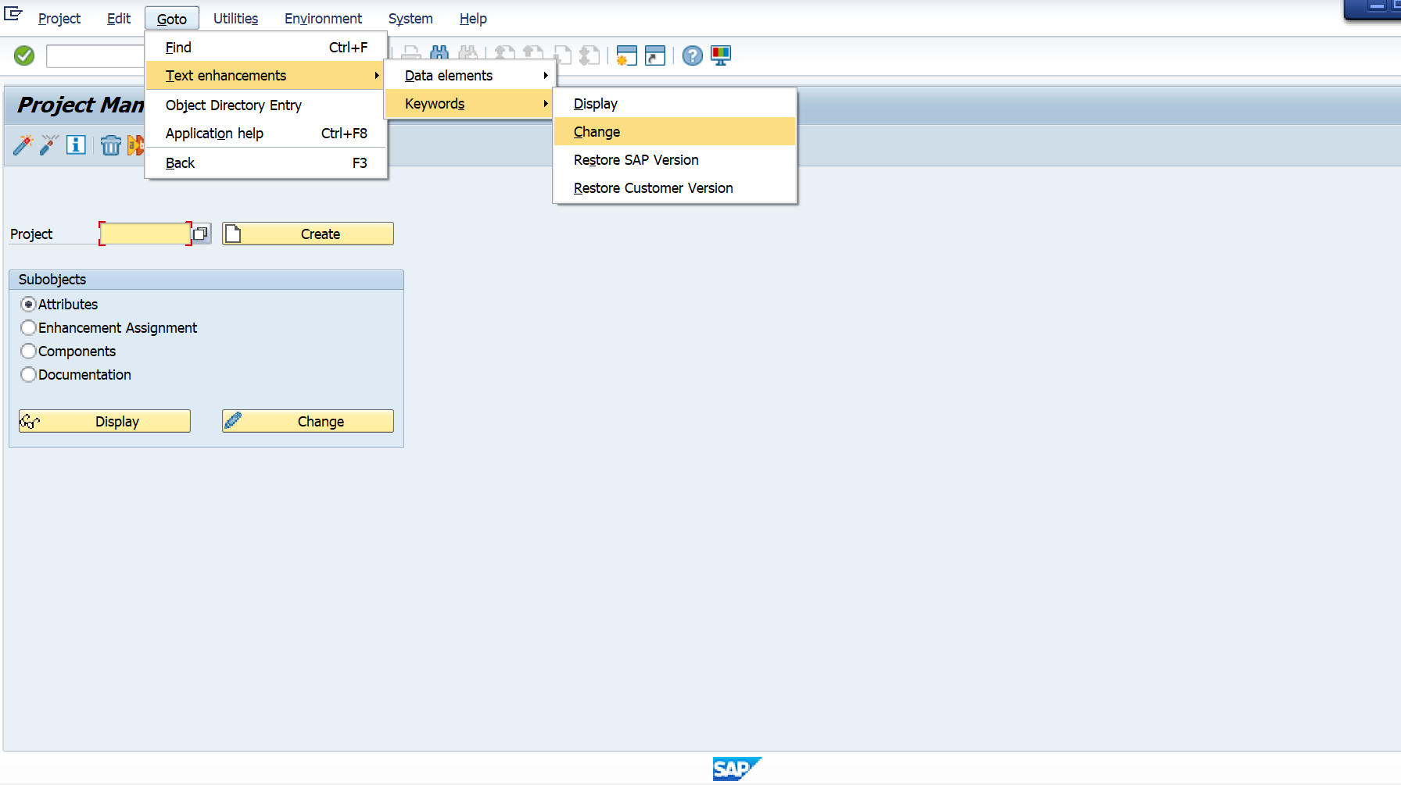

Airline carrier - CARRID - S_CARR_ID

Flight number - CONNID - S_CONN_ID

Carrier Dare - FLDATE - S_DATE

Carrier Fare - PRICE - S_PRICE

Carrier type - PLANETYPE - S_PLANETYE

**Airline carrier - CARRID - S_CARR_ID:**

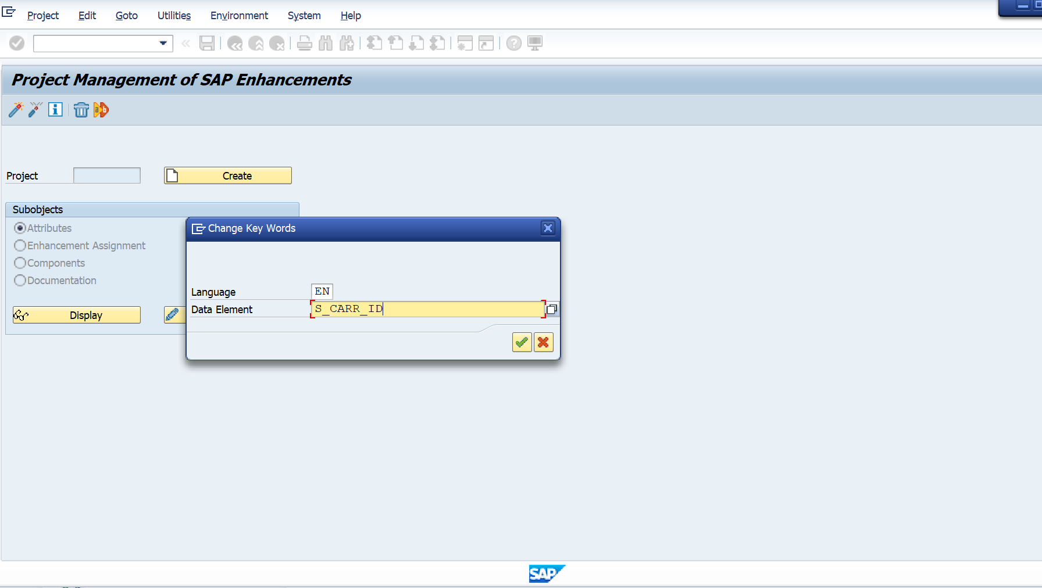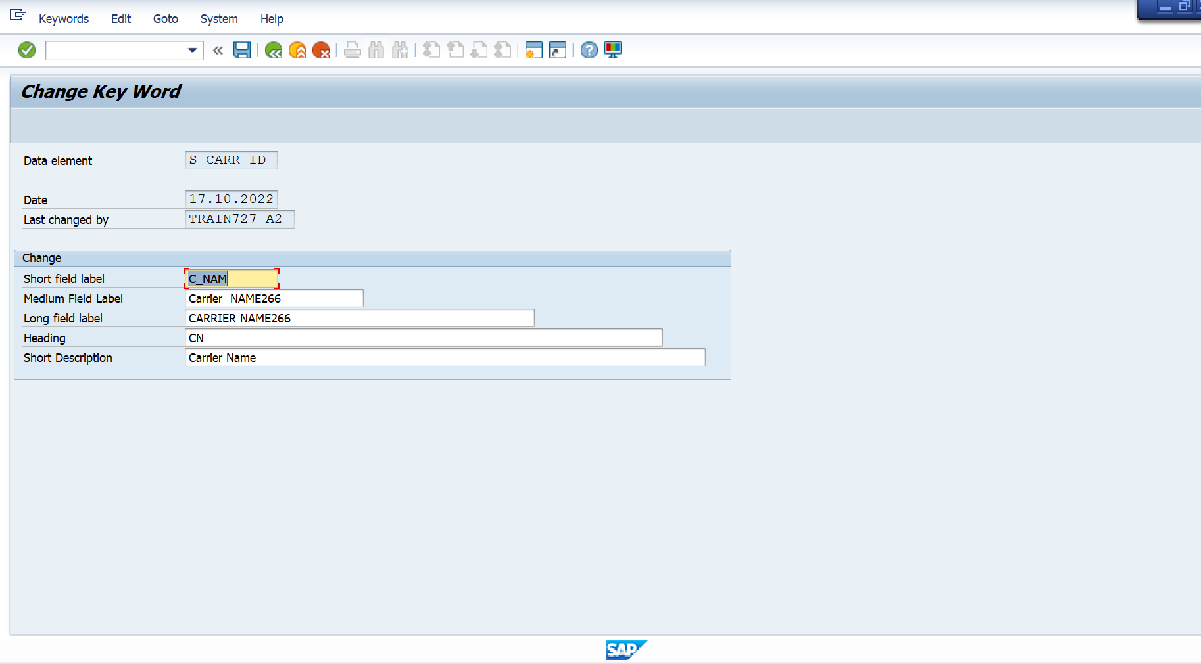**Flight number - CONNID - S_CONN_ID:**

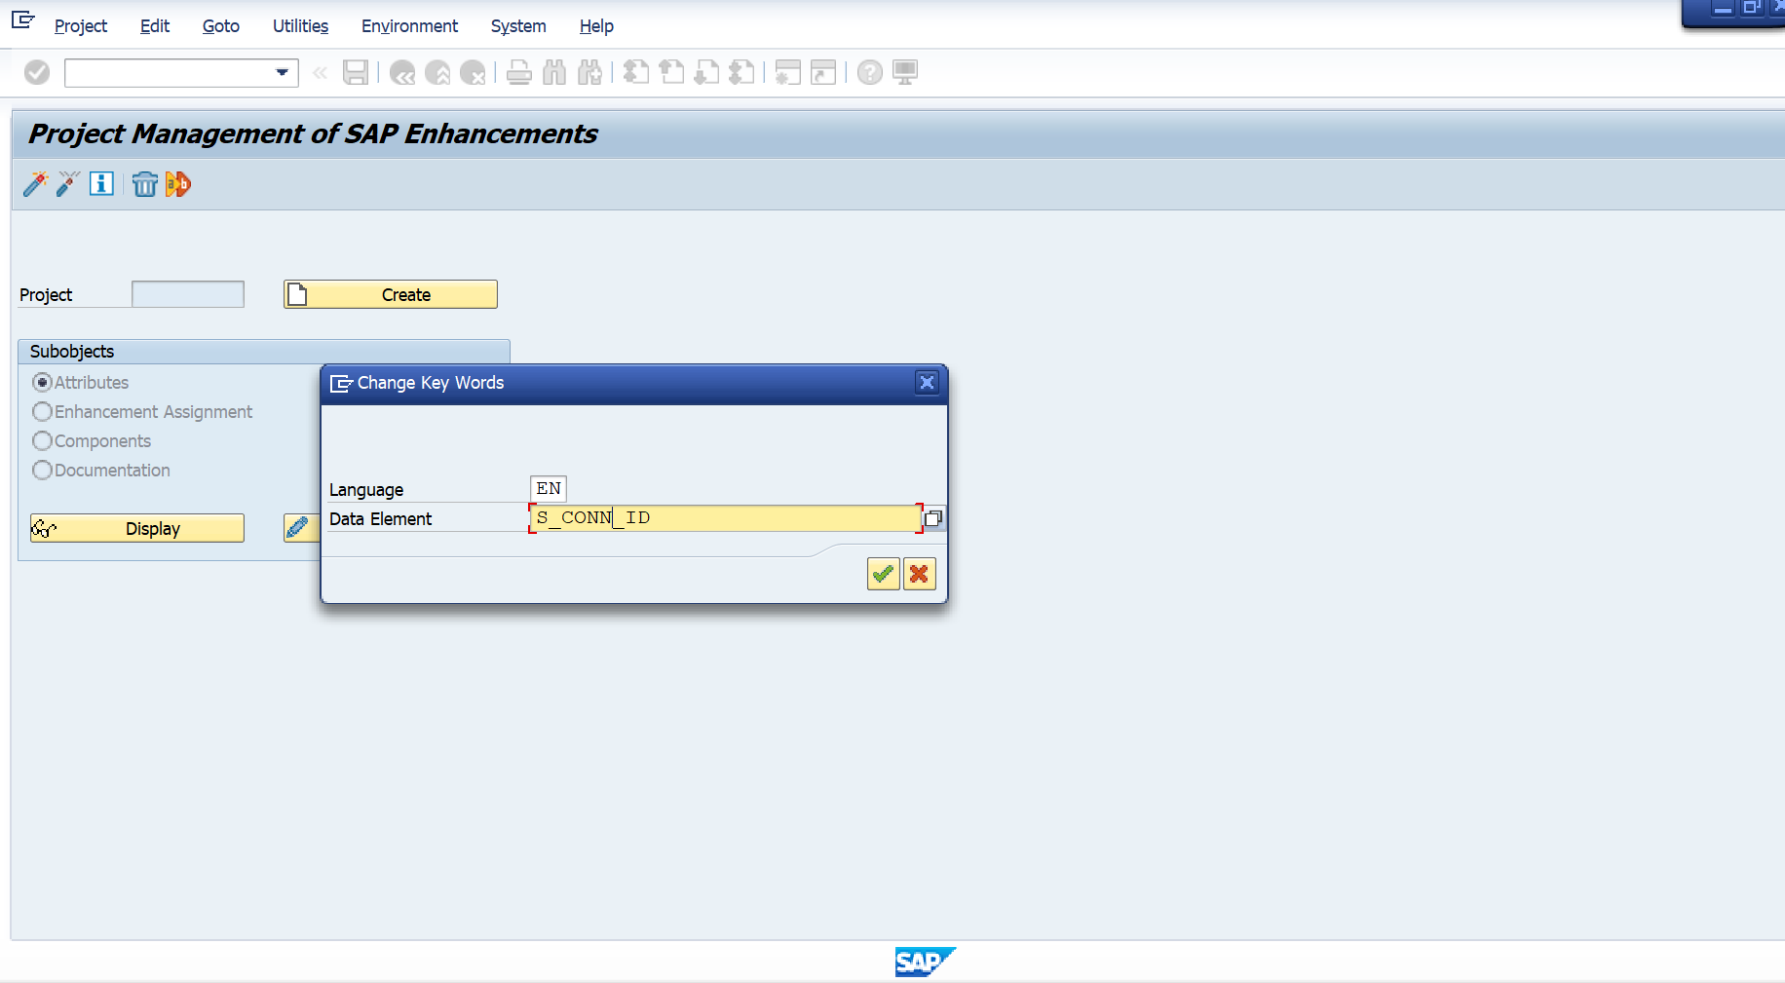

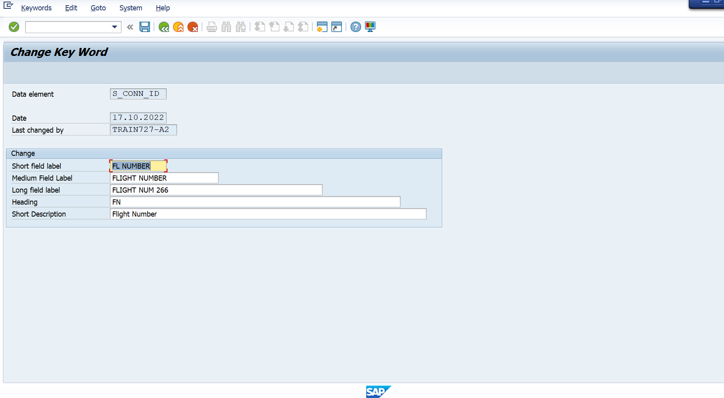

**Carrier Dare - FLDATE - S_DATE:**

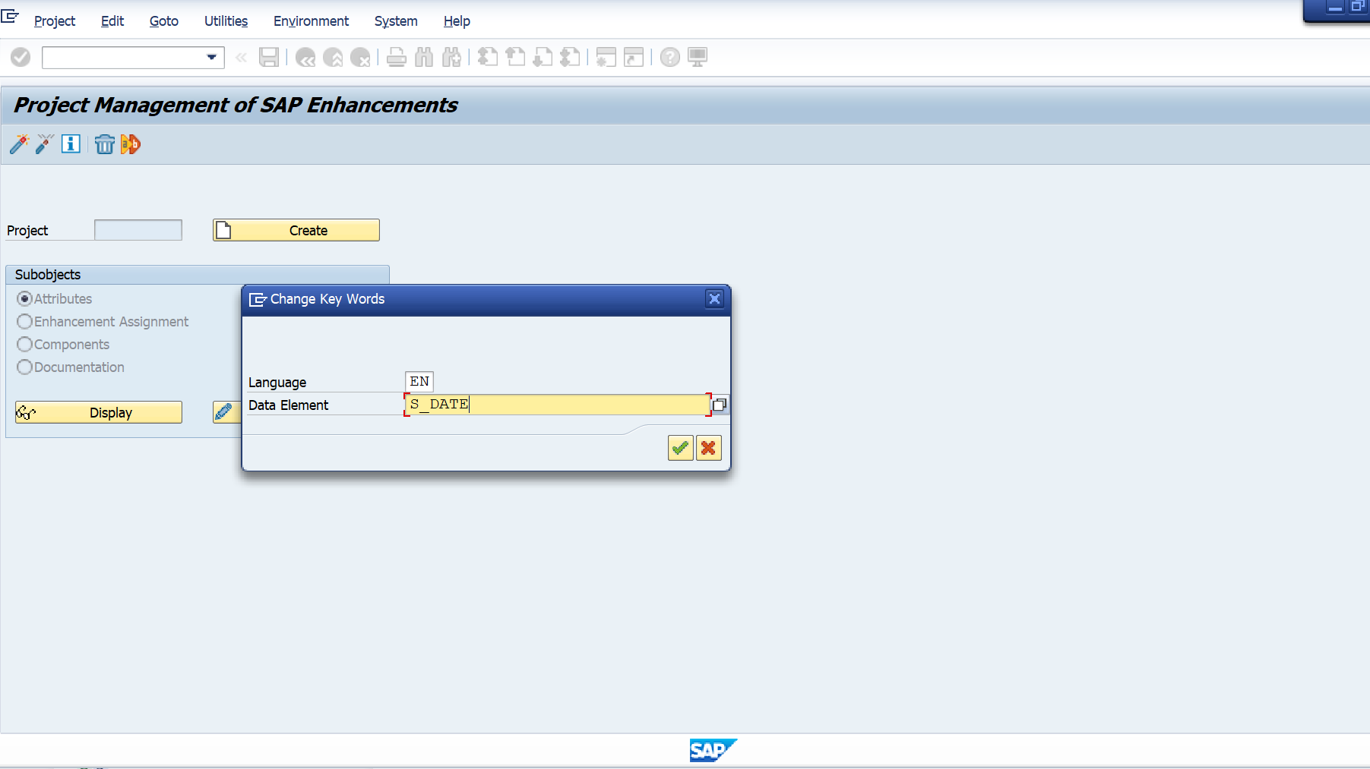

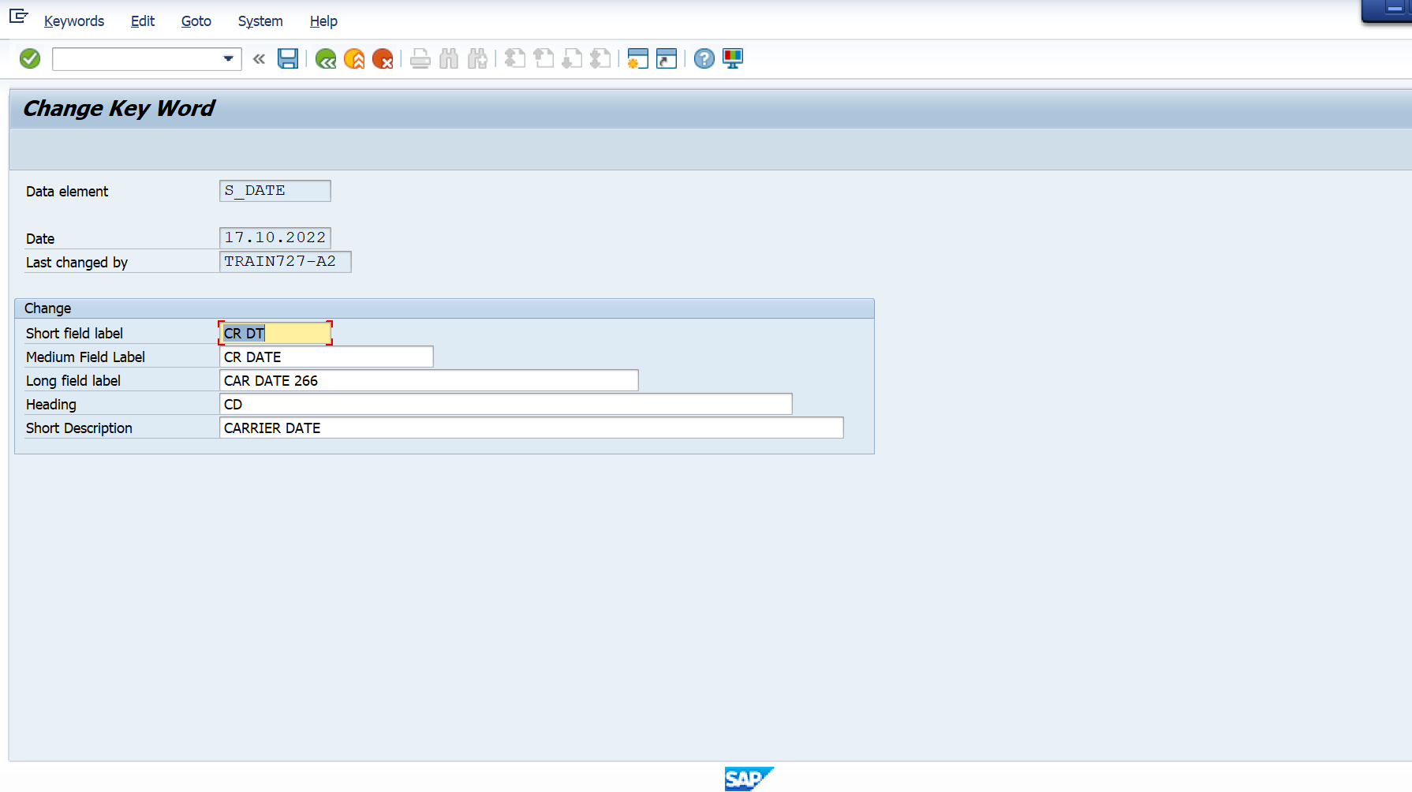

**Carrier Fare - PRICE - S_PRICE:**

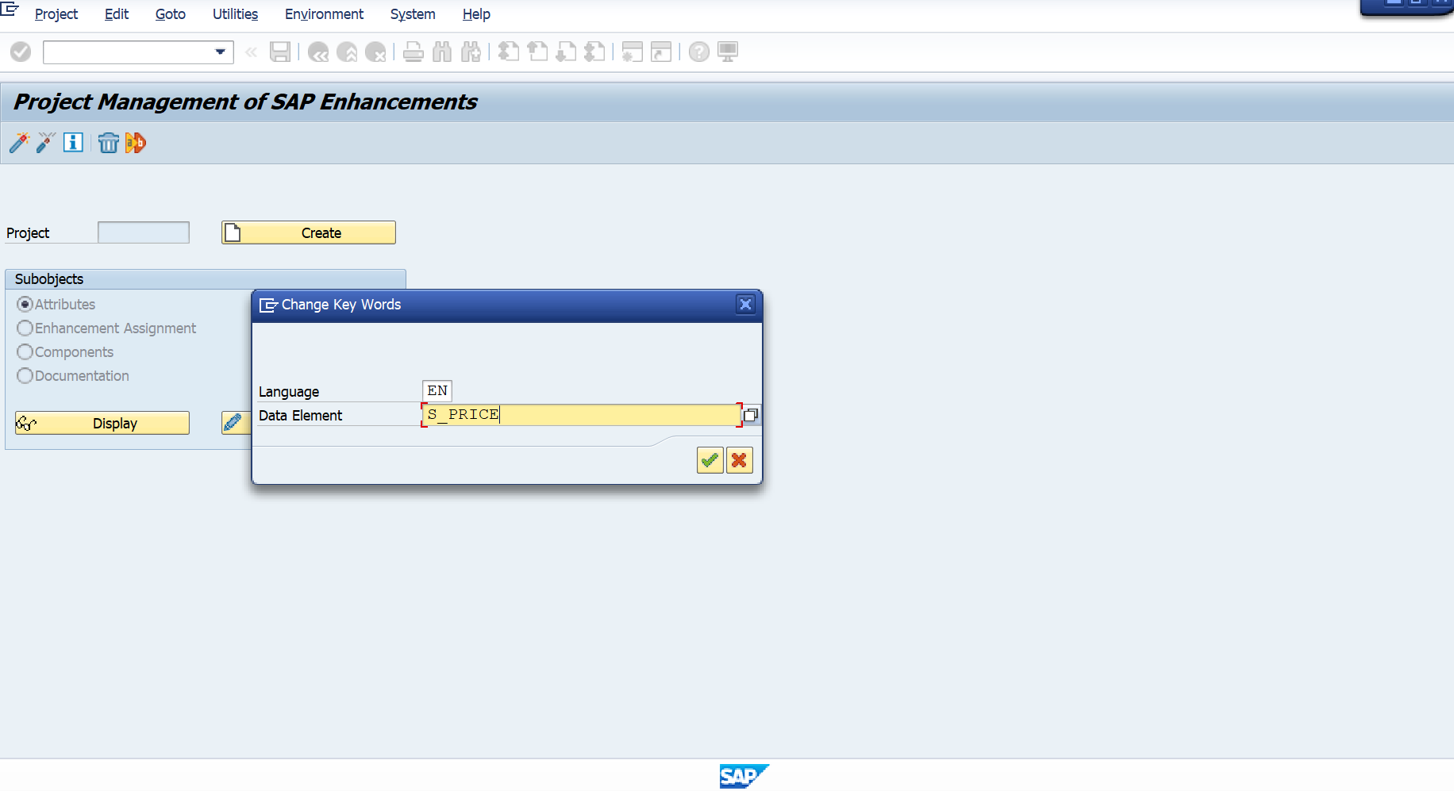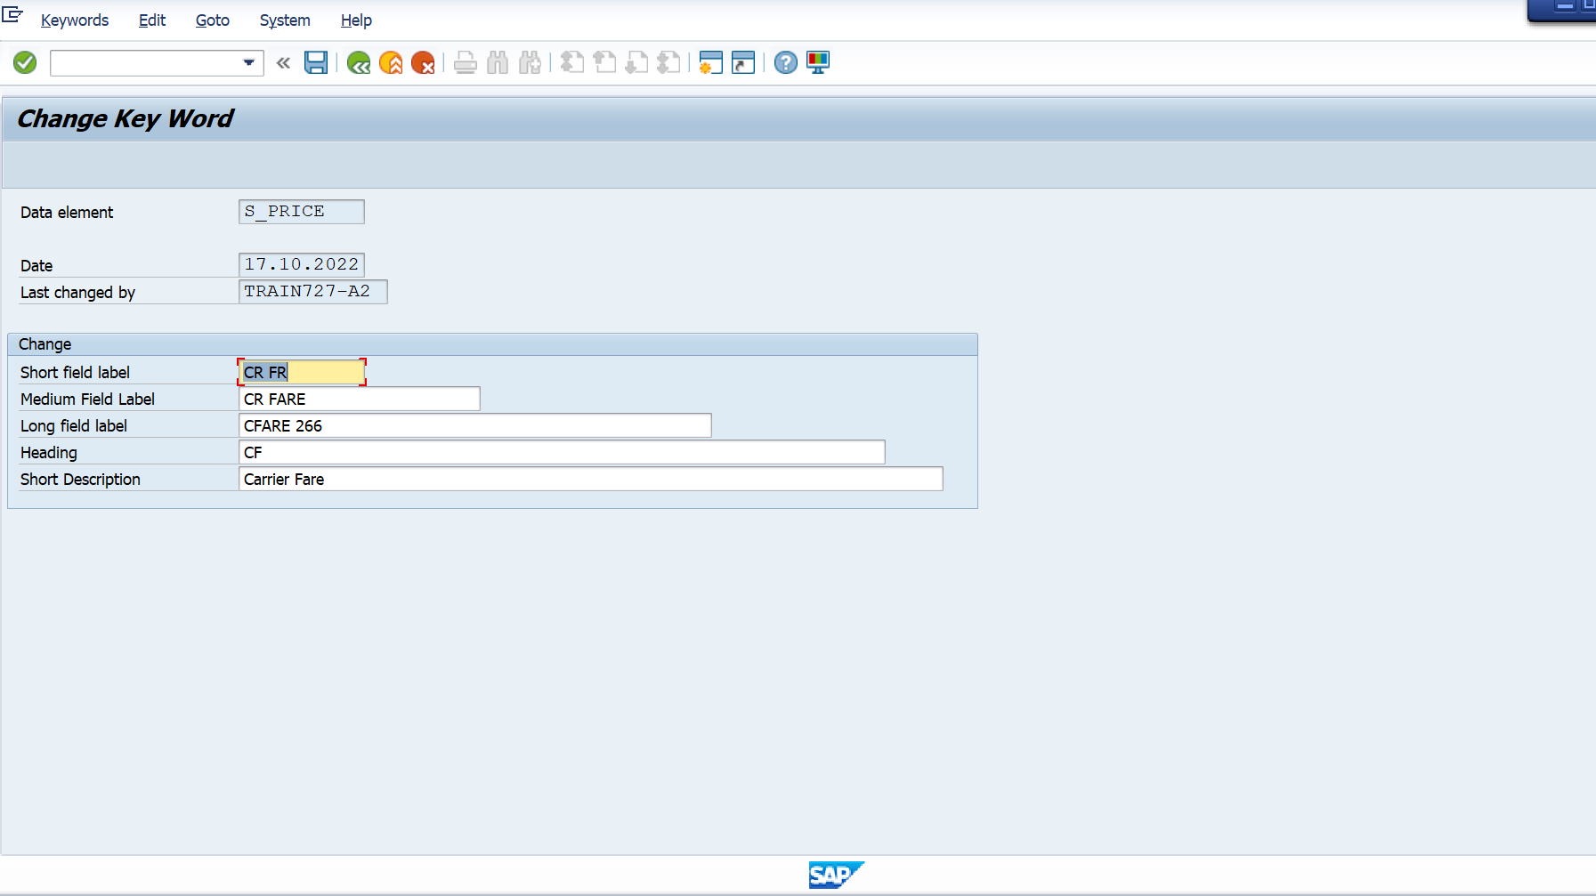

**Carrier type - PLANETYPE - S_PLANETYE:**

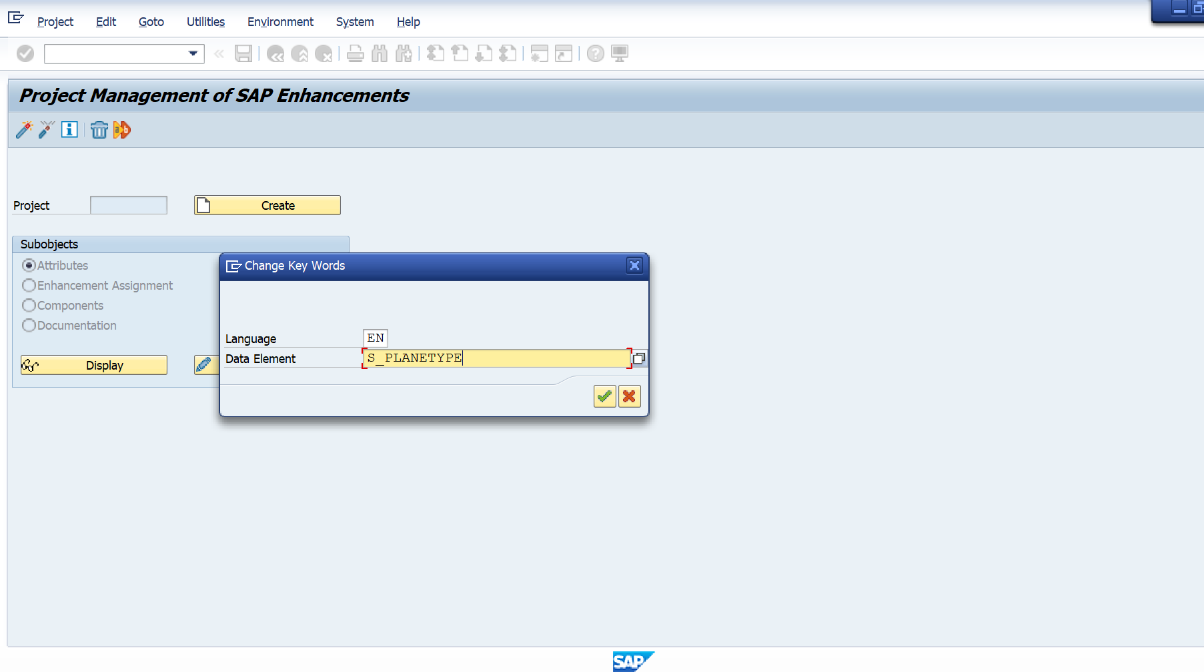

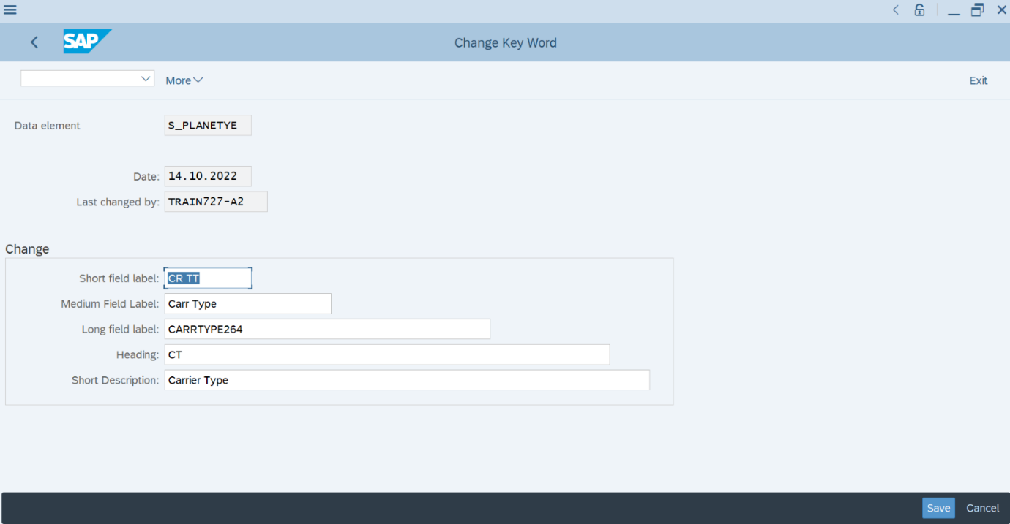

**Documentation:**

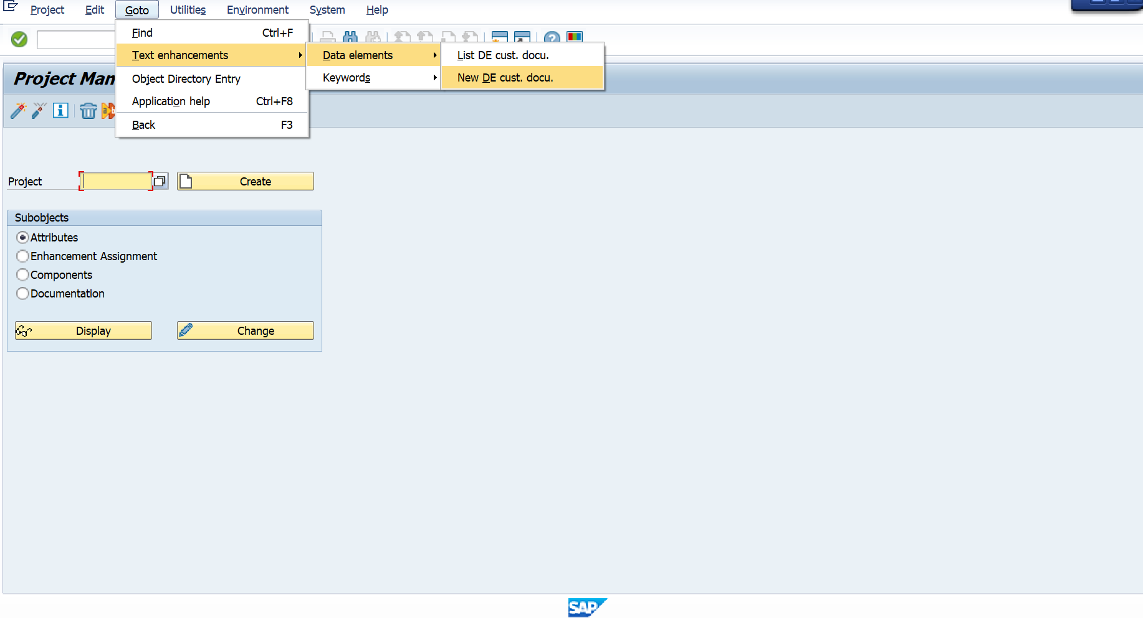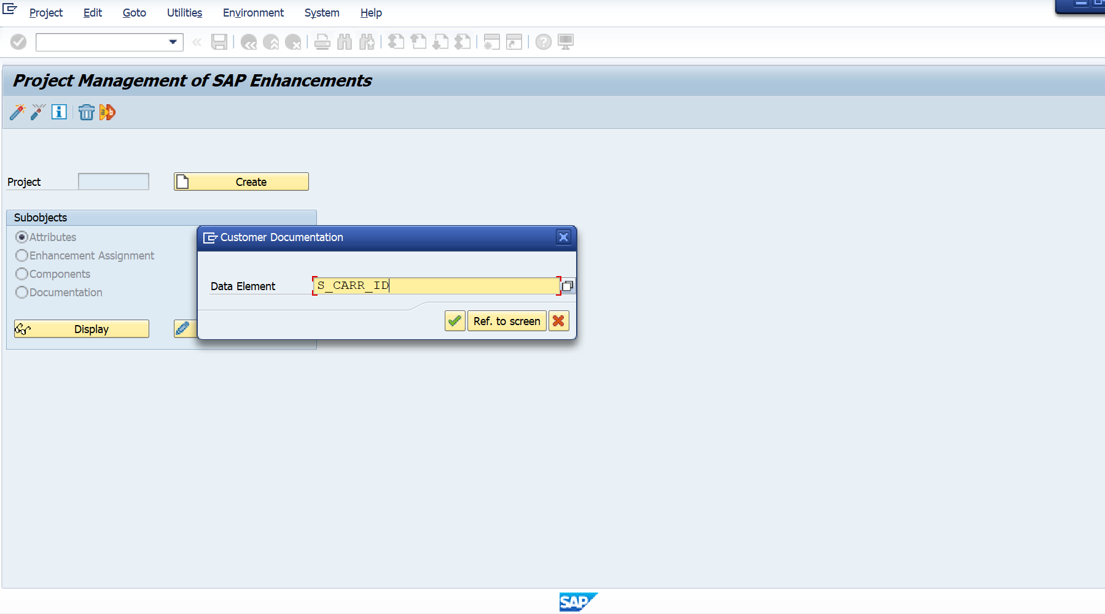

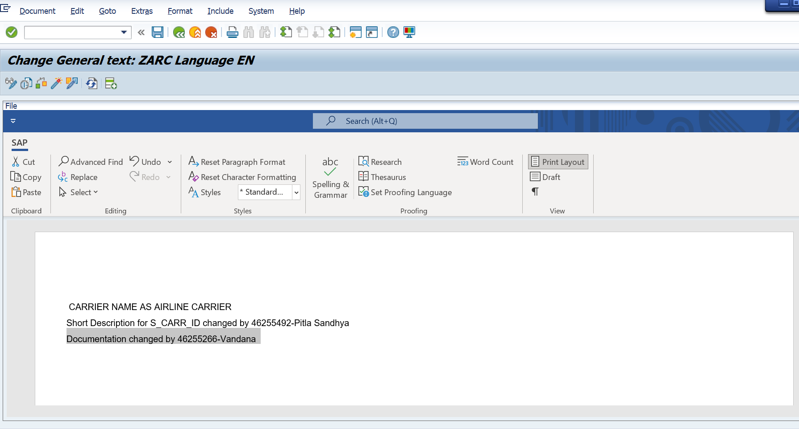

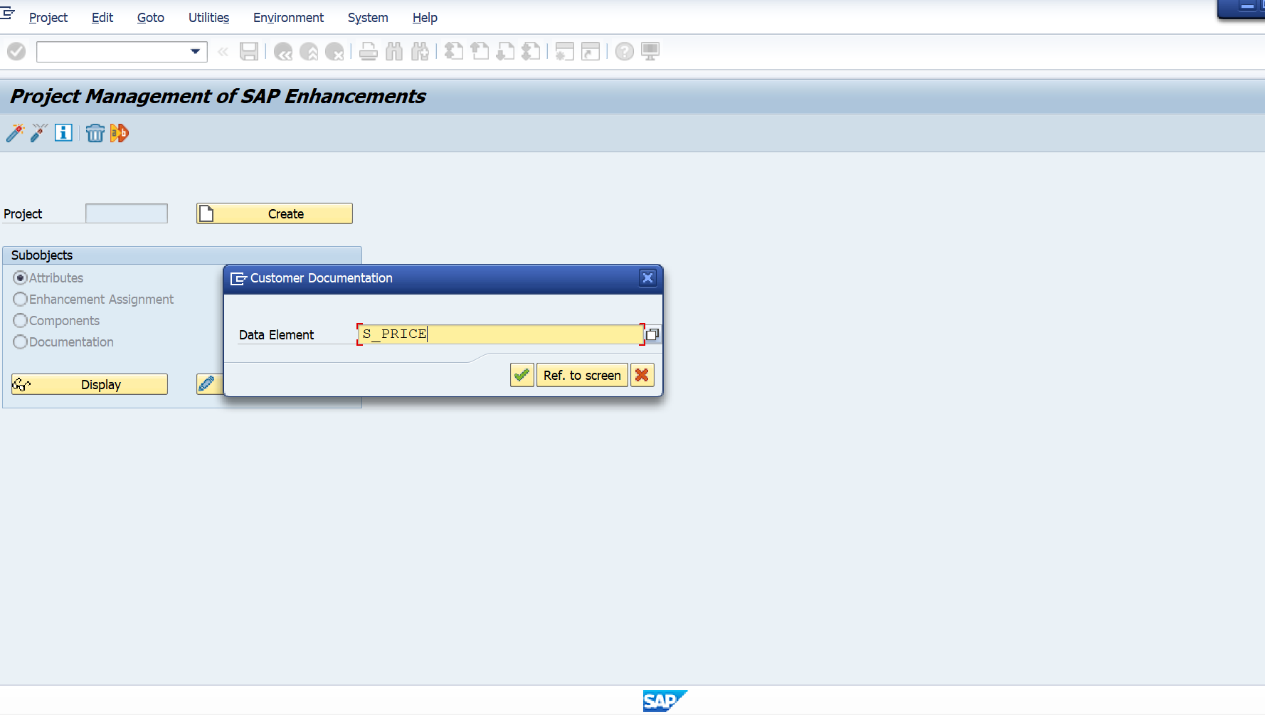

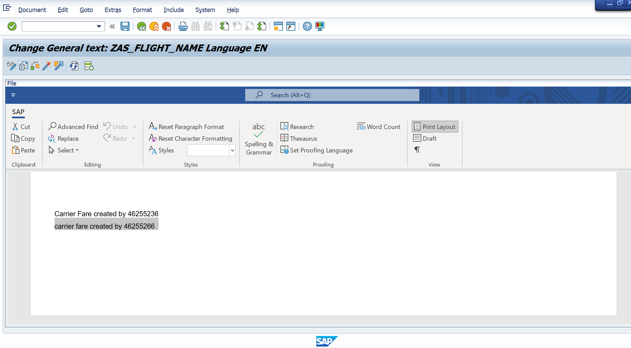

**Exercise 4 – Customer Exits**

1. Create a Customer Exits to set Default Values in a transaction(Example:- VA01, MM01)
2. Create a project in CMOD, Assign Enhancement in Project. Inside Enhancement Module Write Custom Code.

